**ROHAN NYATI**

**500075940**

**R177219148**

**BATCH – 5 (Ai & Ml )**

**Experiment -4**

What is Random forest Algorithm? What are the advantages of Random Forest Classification algorithm over decision tree algorithm. Implement Random Forest Classification using suitable dataset. Enumerate its advantages and disadvantages.

Random Forest is a popular machine learning algorithm that belongs to the supervised learning technique. It can be used for both Classification and Regression problems in ML. It is based on the concept of **ensemble learning,** which is a process of combining multiple classifiers to solve a complex problem and to improve the performance of the model.

As the name suggests, ***"Random Forest is a classifier that contains a number of decision trees on various subsets of the given dataset and takes the average to improve the predictive accuracy of that dataset."*** Instead of relying on one decision tree, the random forest takes the prediction from each tree and based on the majority votes of predictions, and it predicts the final output.

**The greater number of trees in the forest leads to higher accuracy and prevents the problem of overfitting.**

Random Forest is suitable for situations when we have a large dataset, and interpretability is not a major concern. Decision trees are much easier to interpret and understand. Since a random forest combines multiple decision trees, it becomes more difficult to interpret.

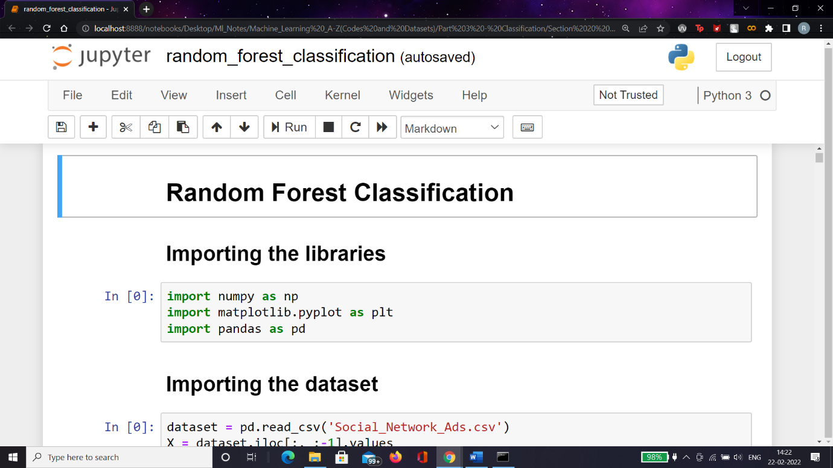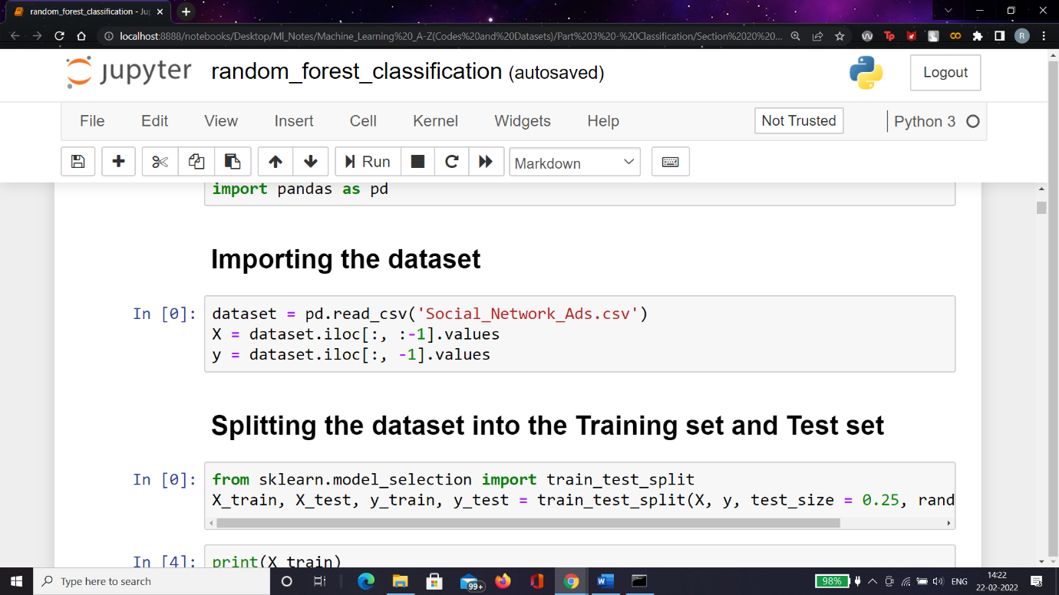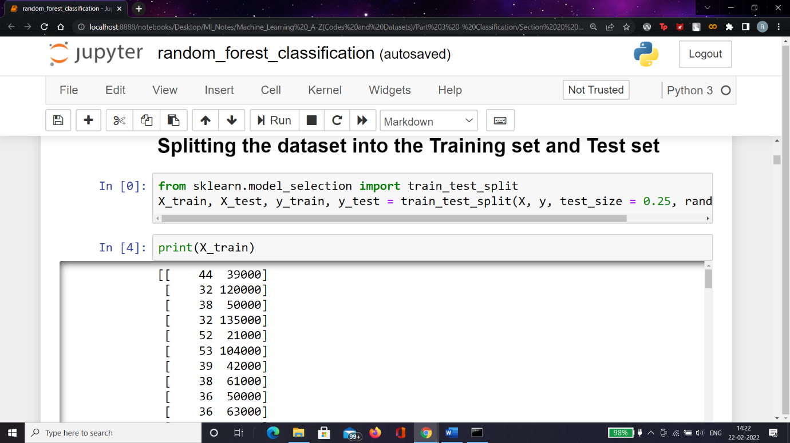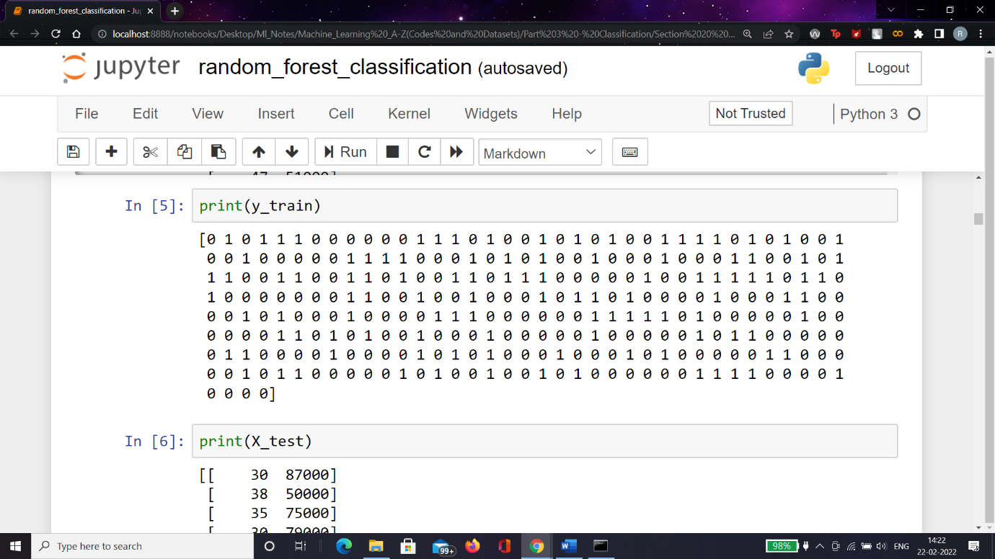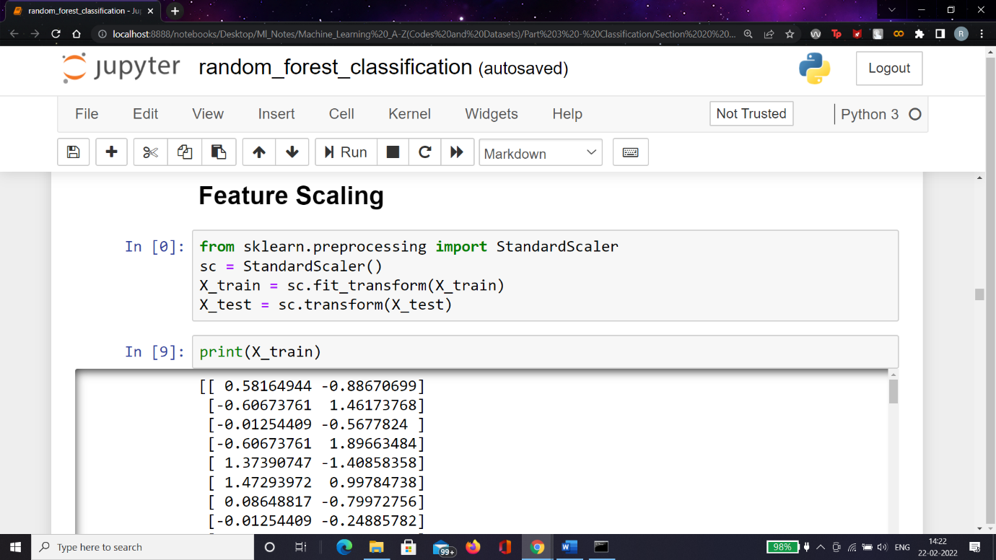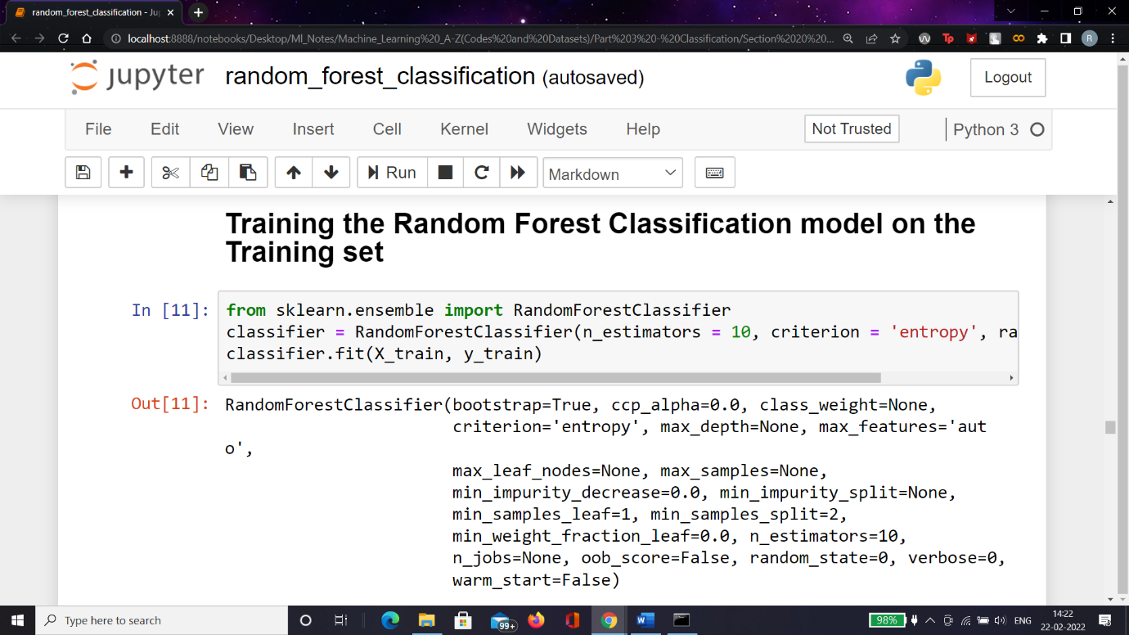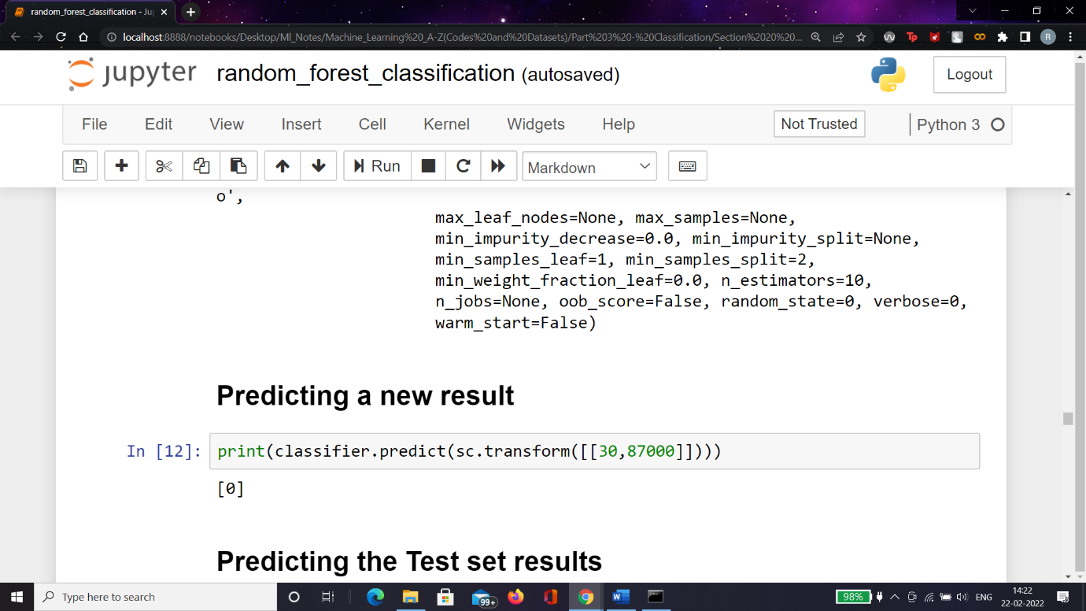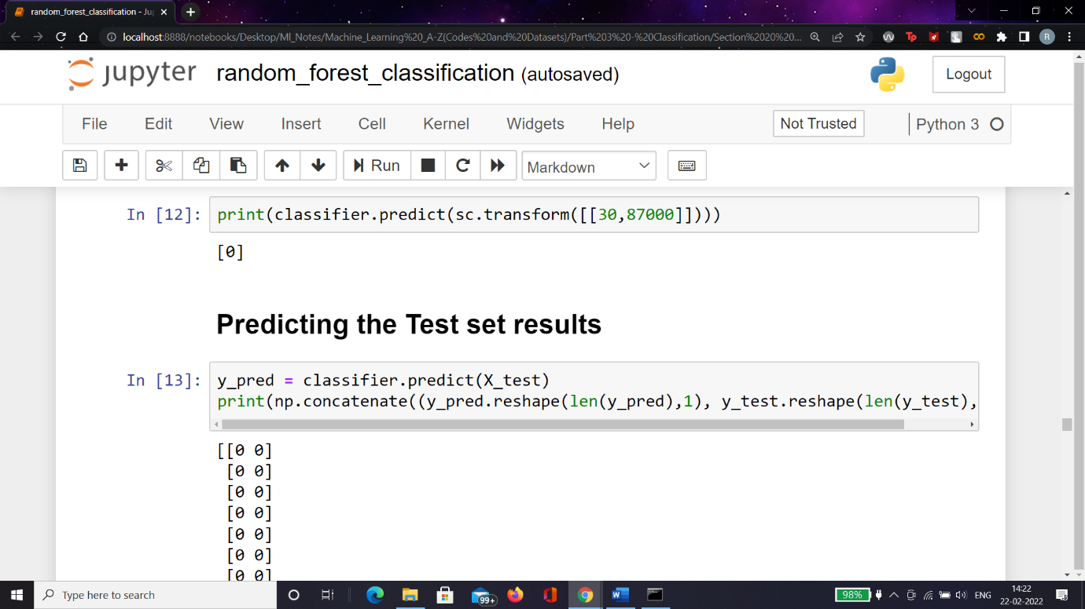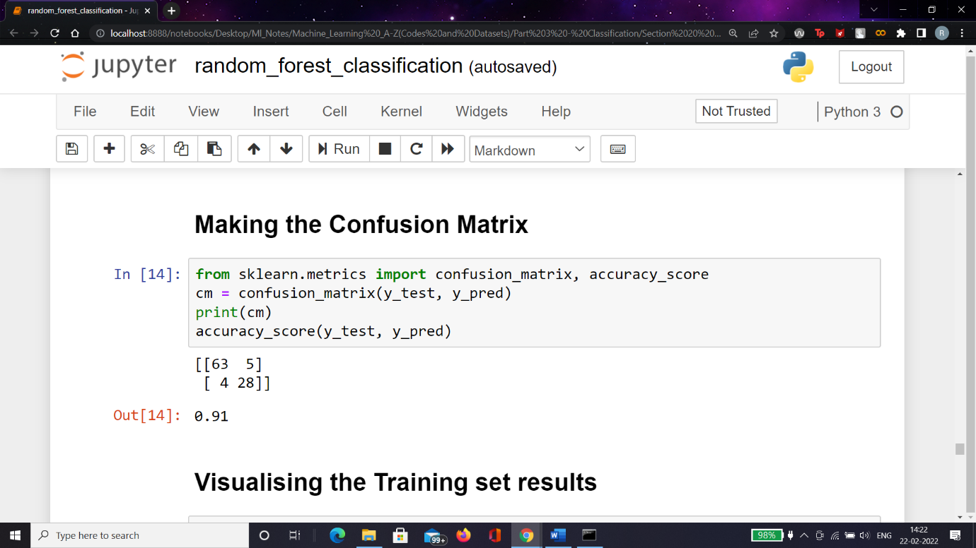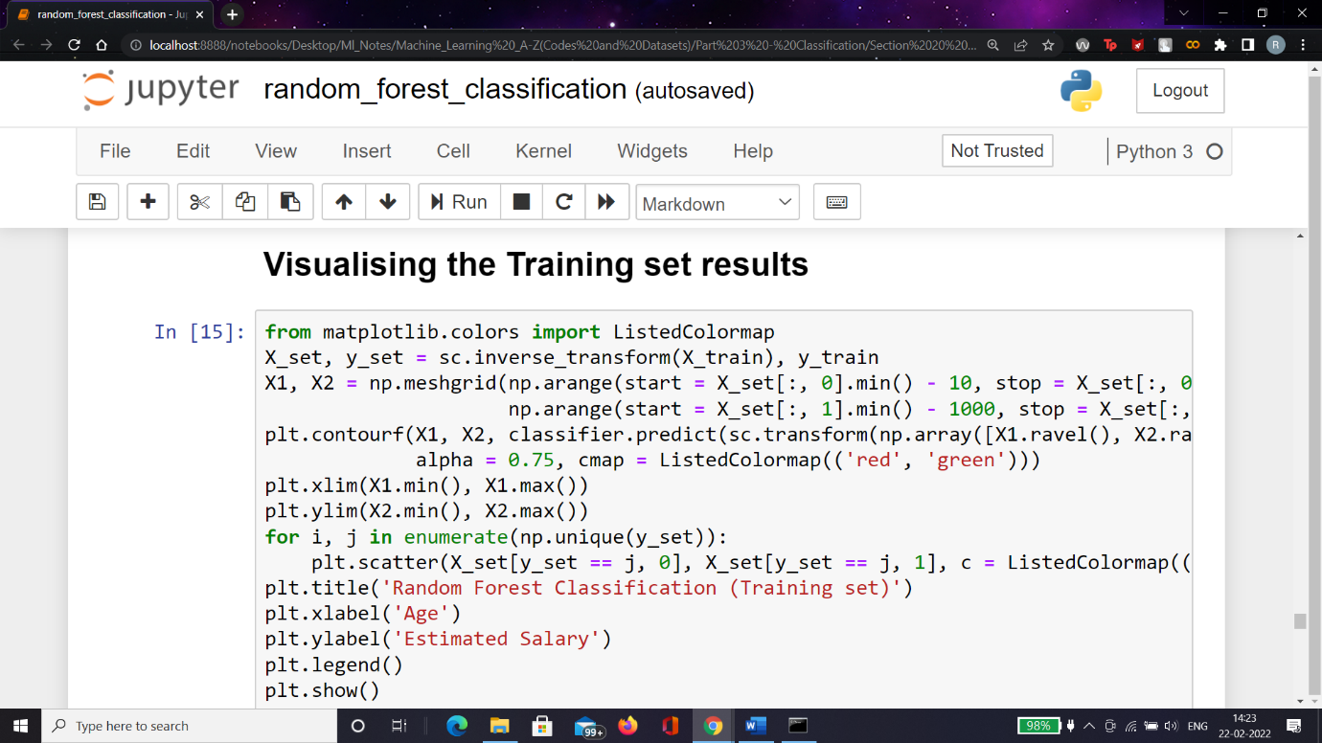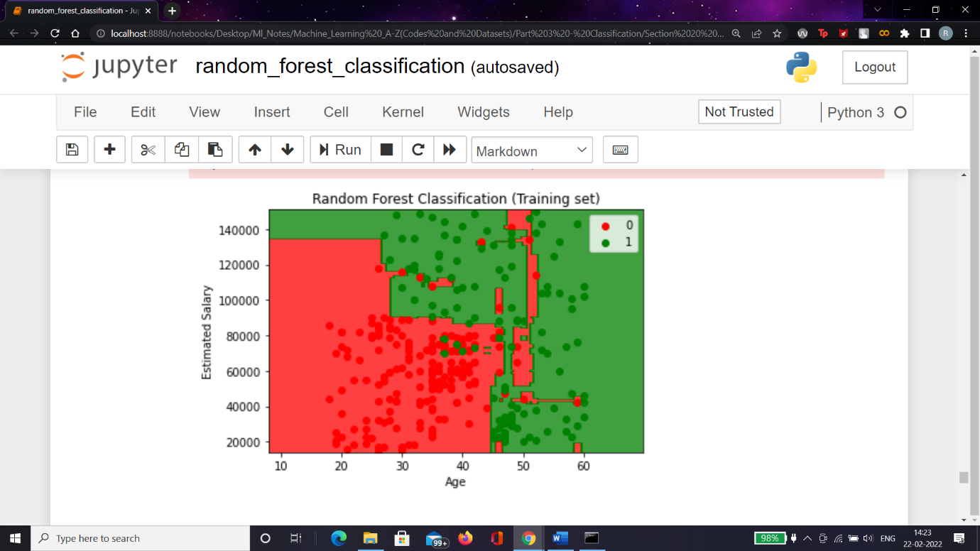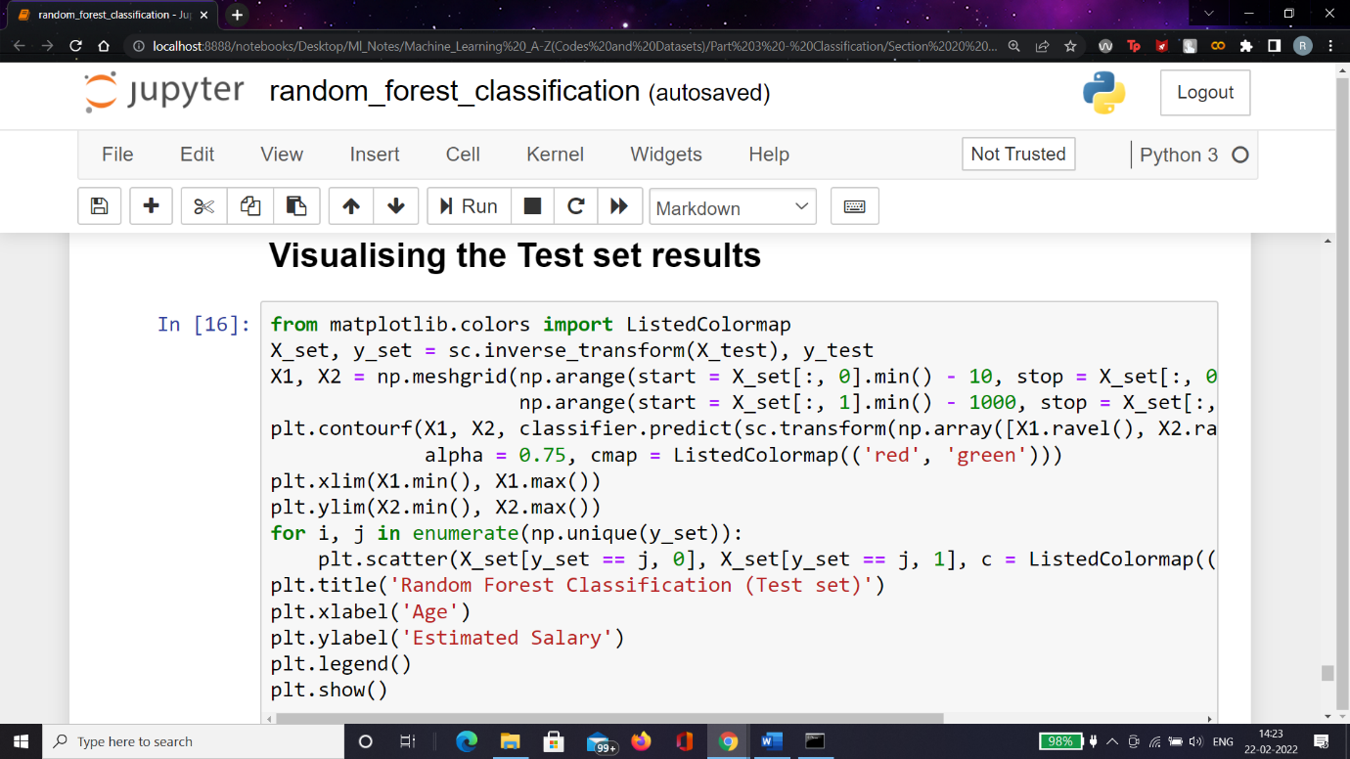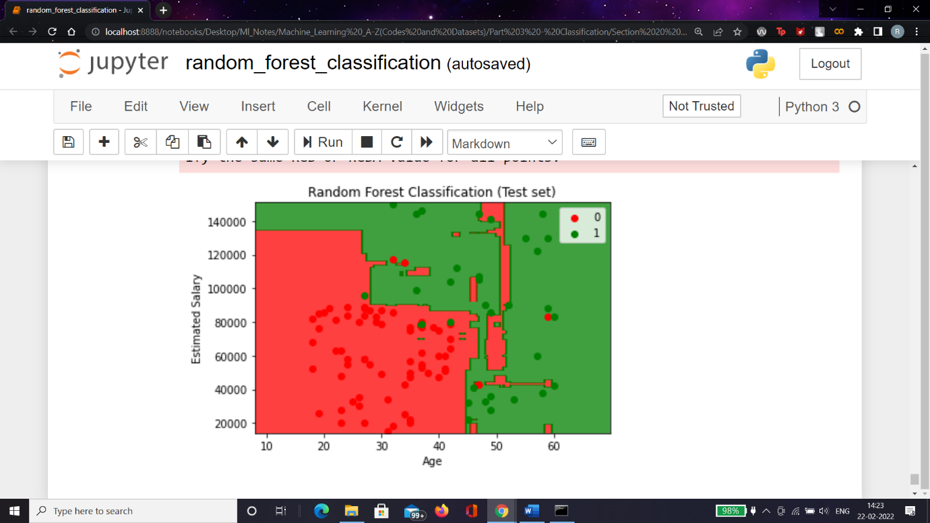

Advantages of Random Forest

* Random Forest is capable of performing both Classification and Regression tasks.
* It is capable of handling large datasets with high dimensionality.
* It enhances the accuracy of the model and prevents the overfitting issue.

Disadvantages of Random Forest

* Although random forest can be used for both classification and regression tasks, it is not more suitable for Regression tasks.